The Secret

To A Happier

Healthier Senior Dog

Learn the true facts about common problems!

We will also tell you the 5 common mistakes to avoid that can shorten their life span or decrease their quality of life

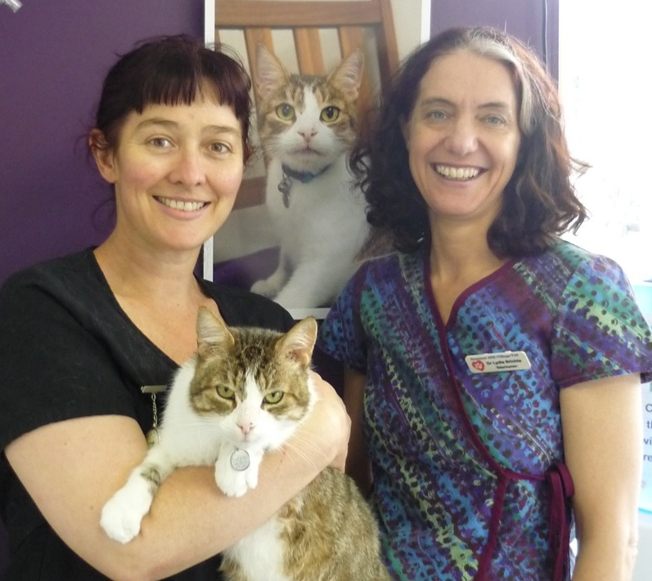
Here at Summer Hill Village Vet we want to give you all the advice and support you need to care for your pet at all of their life stages.

Doctors Sandra Hodgins, Lydia Brichta and their team have decades of years of Veterinary experience between them. They all attend continuing education conferences annually as well as evening lectures and on-line webinars practically every month. Take advantage of this combination of personal experience and the latest information by reading this special report.

How old is your dog really?
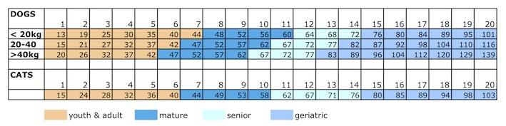
For more in depth information on older dogs read on!

Mature & Senior dogs: 7-12 years of age:
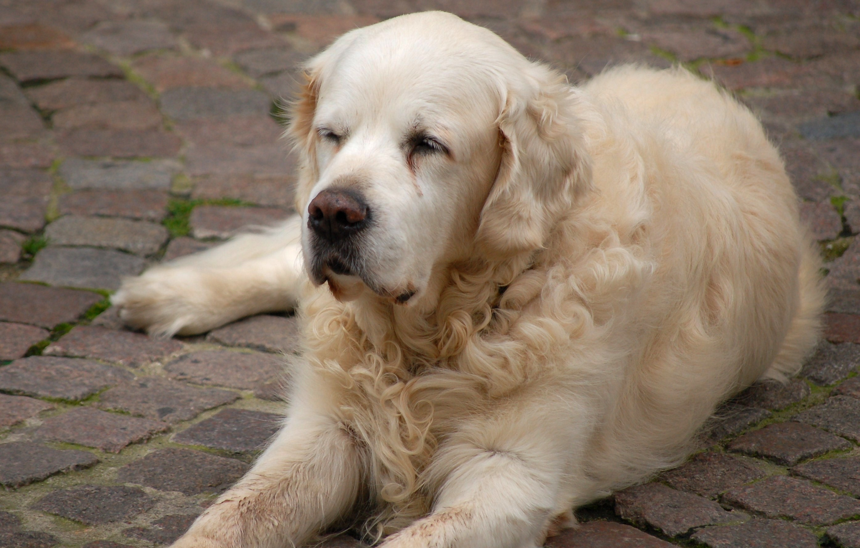
From around 8-12 years of age (younger in large breeds) dogs are in their senior years and this is often the time when age related health problems start to show themselves. A small or medium sized dog of 8 years old is like a human in their late 40’s whilst a giant breed dog of the same age is in their late 50’s.
Dental disease gets more severe and obesity takes a toll on aging joints. We find lumps and bumps start to appear in the skin, arthritis may begin to be a problem, digestive issues like pancreatitis and inflammatory bowel disease become more prevalent, hormonal issues (hypothyroidism, Cushing’s disease, diabetes) appear, and organs may start to fail (kidney failure, liver disease, heart failure).
What you should do:
- At this age, we advise that you present your pet for 6 monthly check-ups. At these check ups we will: assess your dog’s general health, weight and condition; examine the joints; perform a dental examination and discuss nutrition. We will also do a blood test once a year (more often if illness is detected). This gives a base line for comparison with future tests and can pick up issues early.
- From the age of 8 (younger in large breeds) we will not proceed with anaesthesia/ surgery without a pre-anaesthetic blood test and fluid therapy, to speed recovery and minimise risks.

The Truth about Common Problems
Facts about skin lumps:
Most lumps that we see in older pets, especially in the skin, are benign (harmless), and can be left alone (often they are lipomas, a benign fatty lump), but it is always worth getting any new lump checked, because some can be very nasty (eg skin cancer, melanomas and mast cell tumours).
What we do about it:
- If a lump is growing quickly, is painful to touch, irregular in shape and is causing hair-loss or scabbing, then it definitely needs attention and possible removal.
- We can take samples, called Fine Needle Aspirates, before considering removal, to see if the lump is malignant or not, sometimes biopsies are recommended.
Facts about endocrine (hormonal) problems and the major organs:
The clinical signs of many different diseases can look the same so it’s important to investigate further once we notice something odd such as “drinking a lot”. Other problems show up on blood tests long before we see clinical signs. Hormonal imbalances are quite common and most can be successfully treated. Heart disease and kidney disease can’t be cured but we can help your pet have a better quality of life.
What we do about it:
- Pets that drink a lot may have underlying kidney or liver problems or hormonal imbalances, so we always advise a blood test and urine sample to determine the cause. An abdominal ultrasound may be indicated.
- Dogs who “slow down” may have heart disease, low thyroid function, arthritis or weight problems. So we advise investigation which may simply be a treatment trial or may involve blood tests or referral for ultrasound.

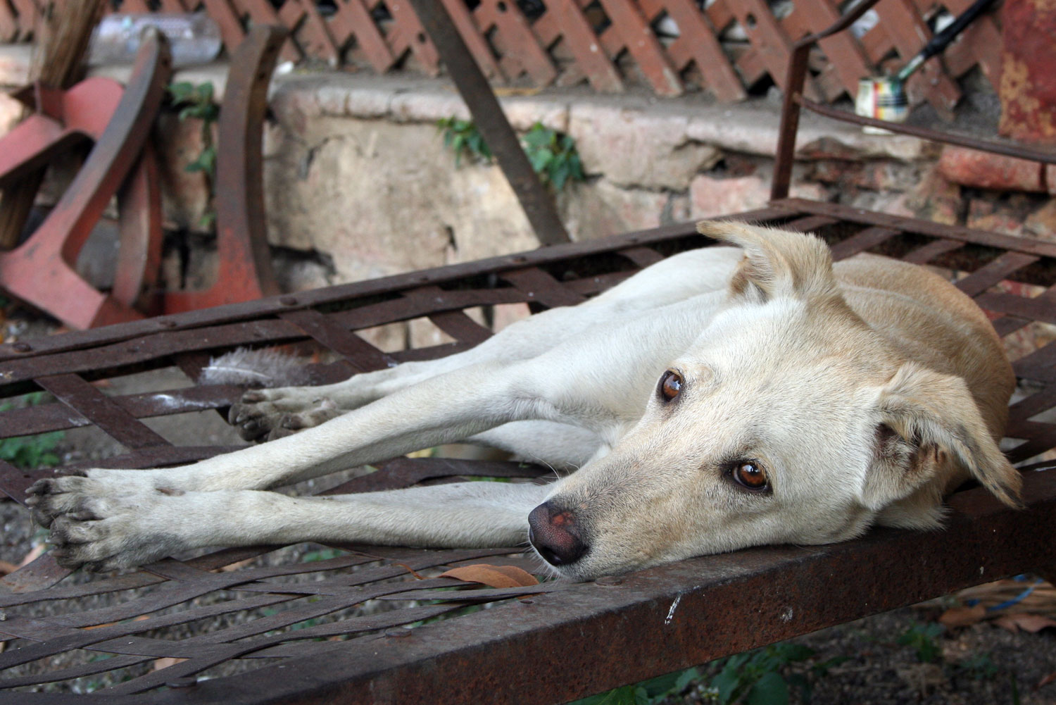
Facts about Chronic disease:
In older age many conditions are chronic and will be with your pet for the rest of their life. For any pet that is on long term medication for one of these conditions, regular check-ups are very important, and are required by law for the clinic to continue to supply medication.

What we do about it:
- Some conditions or medications will require 3 monthly checks and/ or twice yearly blood tests.
- Where possible we always aim to find the least invasive and least harmful treatment option to manage long term disease, and this may involve special diets and nutritional supplements, along with more conventional medications.
Summer Hill Village Vet ph: 02 9797 2555 fx: 02 9797 2566 contact@summerhillvillagevet.com

Facts about Arthritis:
Arthritis is one of the most common degenerative diseases in older dogs and can often be missed by owners until it is quite advanced. Many owners think their dog isn’t in pain because they aren’t crying.
Owners can often mistake a lack of activity or play from a family pet as simply “getting old”, but it may well be the first signs of arthritis. Early treatment can be very effective at restoring your pet’s enthusiasm for life.
What we do about it:
- Exercise, weight control, dietary supplements and Synovan (pentosan polysulphate) injections are all useful approaches to managing early onset of arthritis. Sometimes these alone can reduce the need to go onto long term pharmaceutical anti-inflammatory drugs, however these drugs are available for us to use in animals that continue to experience pain.
TIP: We have an in-depth report on Osteoarthritis In Dogs
and can design an individual care plan for your furry friend.

Facts about Cancer
It is great that pets are living longer lives these days but it is a sad aspect of pet ownership that cancer is now a common illness in older pets. Unfortunately we are diagnosing more senior pets with cancer than ever before.
- Early detection or diagnosis is often the key to effecting cure or remission, and this becomes an important part of your senior health check program.
- Modern surgical techniques have greatly improved survival rates. There are also more medications available and we can refer your pet to a cancer specialist if required.
Diet again plays a key role in supporting the immune system in senior pets, and there are many supplements that can help strengthen the immune system and assist cancer patients enjoy better quality and quantity of life.
Facts about Dental disease:
For a start Dental disease causes serious health issues!
People usually completely under estimate the importance of dental disease to animals overall health and well-being, we may smell bad breath and think nothing of it but this is usually a sign of infection in the mouth and that means serious periodontal disease and that means discomfort and loss of teeth. Pockets of pus around your teeth have to be uncomfortable or even painful. If there is infection in the gum then this releases small showers of bacteria into the bloodstream. This means more work for your elderly pet’s possibly dodgy immune system and can cause small clumps of bacteria spreading to the heart valves or the kidneys.
Summer Hill Village Vet ph: 02 9797 2555 fx: 02 9797 2566 contact@summerhillvillagevet.com

ALERT: Doing nothing about smelly breath will lead to loss of teeth
and may shorten your pet’s life.

If you want your pet to keep their teeth you have to keep them clean! I go to the dentist twice a year and even though I brush & floss my teeth twice a day they have to be scaled and polished. Brushing your pet’s teeth, improving their diet, and having veterinary dental work done when needed can all help them be happier, healthier and live longer.

TIP: to help keep their teeth clean
Chewy raw bones (not big hard ones) can be like brushing & flossing for a dog’s teeth, give them a suitable bone for their size at least weekly. A raw chicken neck or even a wing will really massage the gums & scrape tartar off the teeth for a little dog. Special diets and treats can clean the teeth too. And we have supplements that reduce plaque.

Geriatric dogs: 12 years plus:
From the age of 14 onwards, geriatric pets face an increasing chance of developing illness and degenerative diseases, and many will already be managing arthritis, heart problems, kidney disease etc.
Loss of hearing, vision impairment, cognitive dysfunction (dementia) and spinal degeneration can all play a part in the “ageing” process – but many of these conditions can be helped by your veterinarian. You may be pleasantly surprised by what can be treated these days!
A 14 year old small or medium sized dog is in their 70’s in human terms whilst a giant breed dog is now almost 90! Check ups are now more important than ever to detect and treat health complaints as soon as possible to reduce their impact and keep your old friend as healthy and happy as possible – help your dog age gracefully and comfortably !
Summer Hill Village Vet ph: 02 9797 2555 fx: 02 9797 2566 contact@summerhillvillagevet.com

What you should do:
- We advise at least 2 visits per year.
- Wellness profiles and thyroid checks are very important at this age so blood tests should be done annually.
- Always tell your Vet if something has changed since the last visit even if you’re not sure it’s important.
Many pets do end up on long term medications for arthritis, heart failure, thyroid problems, adrenal issues … and all of these will require regular blood testing to ensure efficacy and safety.
Old age is a slowing down of the body’s repair and maintenance processes, and some of this is due to poor digestion and absorption at the level of the gut. Simple diet changes, and the addition of pro-biotics and anti-oxidants, can help to restore health and vitality to many geriatric pets – so don’t just assume that old age means declining health!

Facts about cognitive dysfunction (doggie dementia):
Age-related behaviour changes can be very frustrating: including house-training problems, disorientation, confusion, restlessness, getting stuck in corners, sleep disturbances, barking etc. Progression of these signs is very gradual; most owners fail to recognise the early stages.
A recent study at the University of California School of Veterinary Medicine demonstrates how common these changes are: out of 69 dogs participating, 32% of the 11-year old dogs were affected by this syndrome and 100% of the dogs 16 years of age older were affected.
What we do about it:
First we need to make sure that there are no other contributing factors that we need to treat, for instance discomfort from arthritis can make a dog restless at night. Then there are not only medications but also dietary changes that can really help. Some therapeutic diets contain antioxidants, mitochondrial cofactors, and omega-3 fatty acids. Improvements have been seen as early as to 2 to 8 weeks after the onset of therapy.
You can also help; in fact in trials the combined effect of a special diet and enriched environment (e.g., housing with another dog, playing daily with toys) provided the greatest improvement in learning ability when compared to the dogs who did not have either dietary or environmental enrichment.

Senior dogs can keep learning, and they love to learn! Now is the time to turn their intelligence toward improving the quality of their lives.
Teach your senior dog signals if the dog’s vision is still good. This will serve as a back-up if hearing fails, which it often does. Signals are fun for dogs and are a more natural language for them than words. Hearing loss can be moderate or profound.
Teach your senior dog composure, with Stay and Settle exercises (Downs without Sits—Sits can hurt) and training that gives the dog safer targets for human affection than jumping up. It’s quite simple to teach a dog to go to people’s knees for petting rather than jumping up for example.
If your dog needs help getting up or walking now and then a special harness may help – ask your Vet.
Five common mistakes:
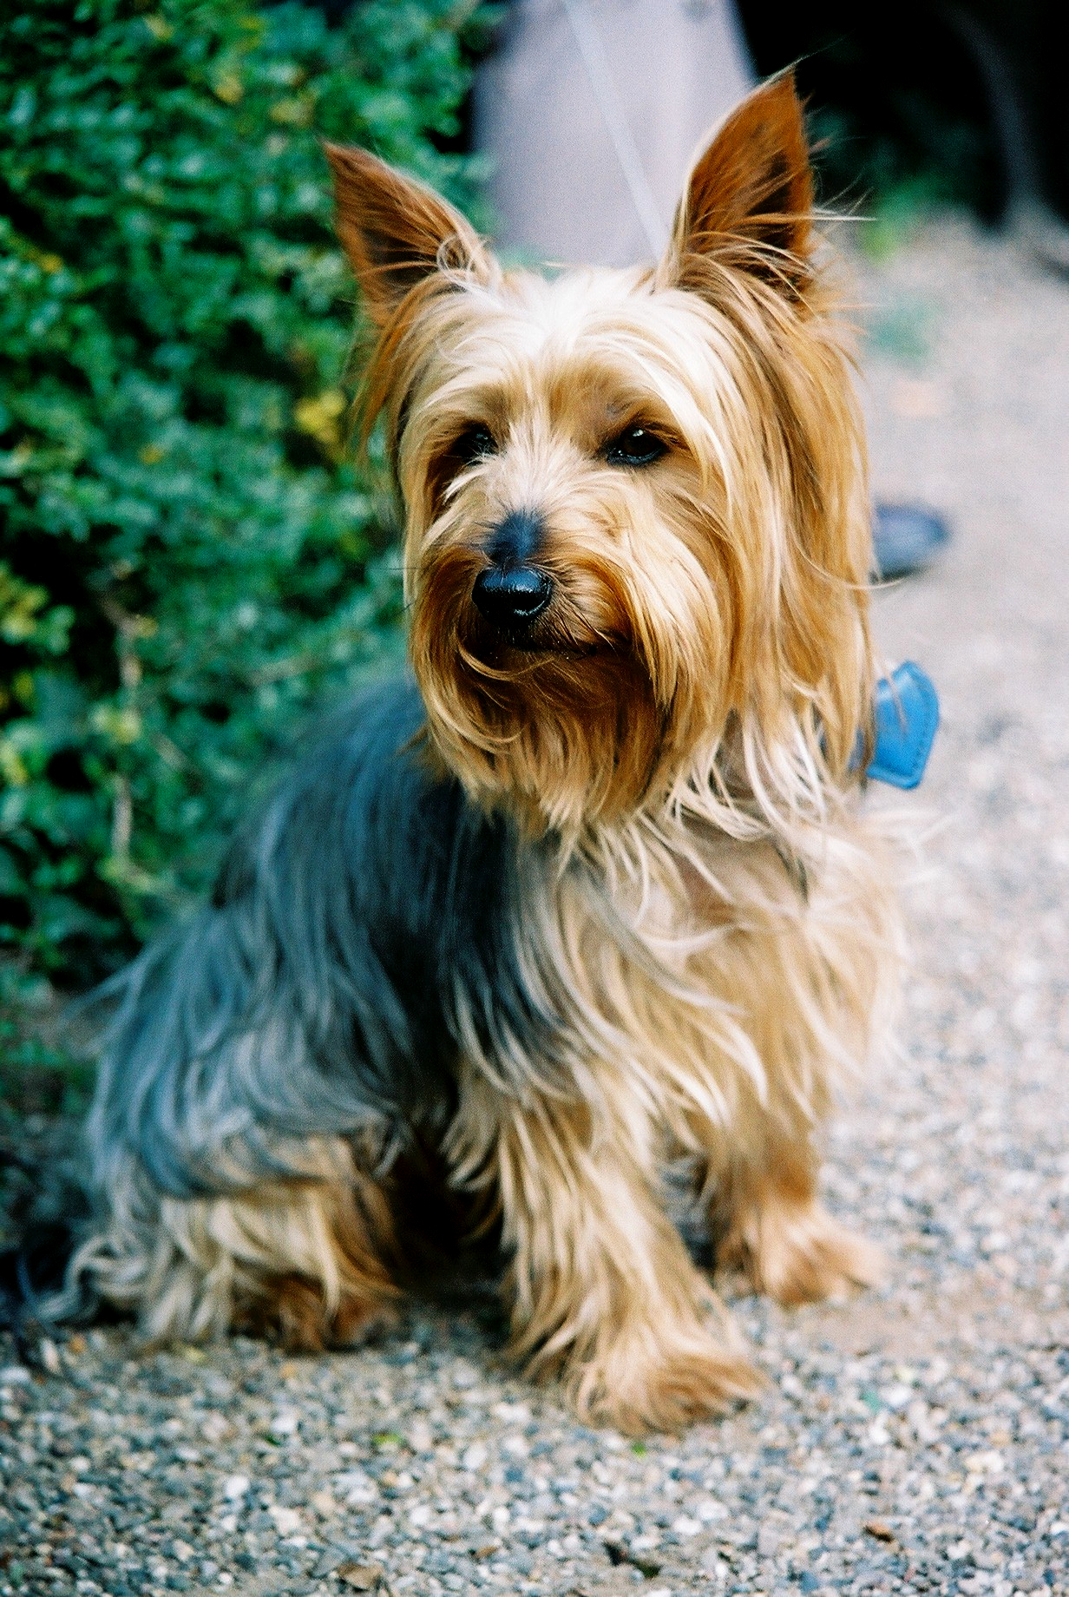
1. Ignoring preventative health care such as vaccinations and worming
2. Not telling the Vet about anything odd you’ve noticed or any changes in behaviour or eating patterns and so on.
3. Not coming in for regular examinations.
4. Assuming treatment is not worthwhile in old patients then regretting the chance to pursue an effective cure later.
5. Attributing low activity levels to “old age” when it is often actually arthritic PAIN.

Older dogs have other care issues: if they have any incontinence you may need to wash them more often or give them bedding that keeps them dry, they may not be so good at grooming themselves any more, - you can make them more comfortable with some more personal beauty care! Steps for getting up onto sofas & special warm beds are all helpful to the older dog, ask us for any extra advice you need.
Summer Hill Village Vet ph: 02 9797 2555 fx: 02 9797 2566 contact@summerhillvillagevet.com

