NOW is the time for your
dog’s Senior Health Check.
10 Reasons why:
There’s nothing like the love and companionship our pets give us over the years. ALWAYS just happy to be there … for you.
So when your pet reaches the ‘golden years’ of life, it’s time to celebrate!
Of course, with age comes extra care. Just as our bodies complain a little more as we grow older, the same is typically true for our pets. The trouble is … they don’t have the WORDS to TELL you what’s hurting or aching.
That’s WHY we believe so strongly in screening for age related diseases at this time in their life. The reasons to do so ARE compelling. The great news is most of these are treatable IF they are diagnosed early on.
10 good reasons for you to arrange for that SENIOR CHECK-UP now:
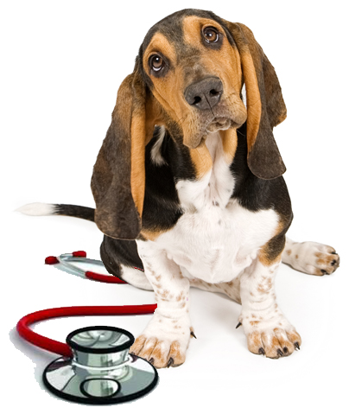
- 50% of dogs over 10 have arthritis
- 41% of dogs at 10 years of age are obese
- 10% of dogs over 10 have kidney disease
- 12% of dogs have chronic liver disease
- 6.5% of dogs have stones in their bladder
- 78% of dogs over 3 years have dental disease
- 12% of dogs over 8 have heart disease
- 20% of female dogs over the age of 8 have urinary incontinence
- 12% of dogs have severe hormone imbalance causing life threatening conditions
- 32% of pets die from cancer. Females are 3 times more prone to it. Up to 25% of dogs over 8 have skin tumours
These facts are not to alarm. It’s simply our commitment to make your pet’s golden years as pain free and enjoyable as possible. We’ll discuss with you what we do to ensure early diagnosis of any of these senior diseases.
Life is busy. But please don’t put this off. So please call us to book an appointment in the next 10 days schedule a SENIOR CHECK-UP now.

