NOW is the time for your
cat’s Senior Health Check.
10 Reasons why:
There’s nothing like the love and companionship our pets give us over the years. ALWAYS just happy to be there … for you.
So when your pet reaches the ‘golden years’ of life, it’s time to celebrate!
Of course, with age comes extra care. Just as our bodies complain a little more as we grow older, the same is typically true for our pets. The trouble is … they don’t have the WORDS to TELL you what’s hurting or aching.
That’s WHY we believe so strongly in screening for age related diseases at this time in their life. The reasons to do so ARE compelling. The great news is most of these are treatable IF they are diagnosed early on.
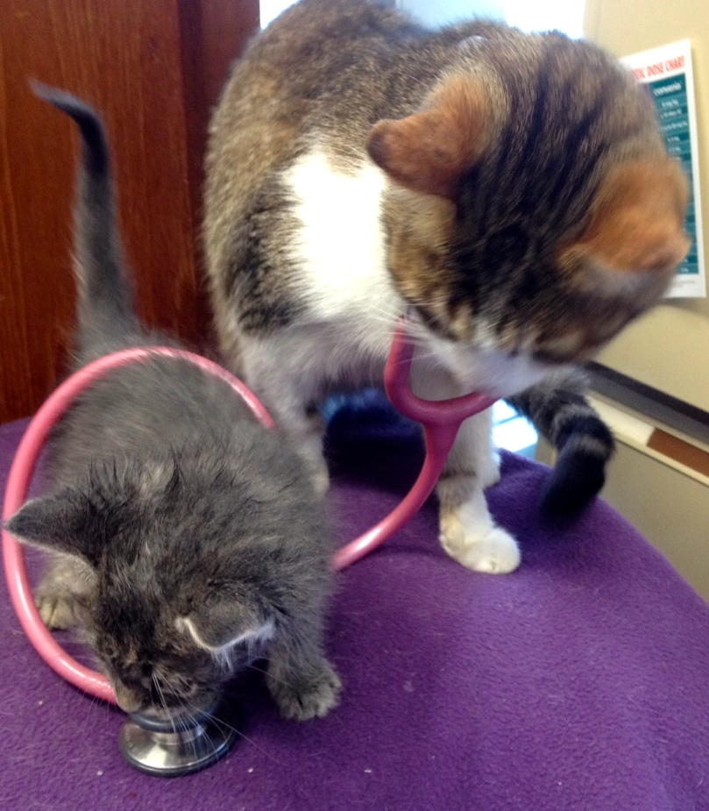
10 good reasons for you to arrange for that SENIOR CHECK-UP now:
- 32% of pets die from cancer.
- 68% of cats have dental disease
- 50% of cats over 5 have arthritis
- 35% of cats over 8 have kidney disease all
- fat cats are very likely to get diabetes
- 10% of cats over 10 years of age will develop Hyperthyroidism
- cats in pain do not cry and often show no obvious signs at all
- 30% of cats over 12 years have significantly reduced digestion – thin cats need help
- 25% of senior cats have high blood pressure which causes kidney damage and can cause blindness
- 36% of cats over 11 years have behavioural changes (which can be caused by underlying medical conditions or even dementia)
These facts are not to alarm. It’s simply our commitment to make your pet’s golden years as pain free and enjoyable as possible. We’ll discuss with you what we do to ensure early diagnosis of any of these senior diseases.
Life is busy. But please don’t put this off. So please call us to book an appointment in the next 10 days schedule a SENIOR CHECK-UP now.

