Caring for the Robert De Niros

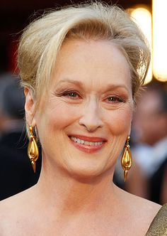
of the cat world

(10-14 years)

Or maybe your cat is more of a Meryl Streep?!

Know how to keep your “senior” cat healthy & happy.
Ask for our free Special Report to get more details on how to care for your cat.

1. Catch problems early – get regular check ups

Early recognition of disease allows us to start treatment promptly and so maintain your cat’s quality of life for as long as possible. It’s as true for cats as it is for people that early treatment is the most effective.

The major problems we look for in old cats are: kidney disease, hyperthyroidism, diabetes, cancer, arthritis, dental disease, hypertension and cardiac disease.

From about 10 years of age your cat is more senior – just like a 60 year old human - and that’s usually when your doctor starts recommending more frequent examinations, regular blood pressure checks and routine blood tests. We recommend that senior cats have a check up twice a year, including a urine test, and a basic blood test once a year. Don’t worry; we can advise you how to collect a urine sample!

A simple test on a urine sample can give a lot of information and rule out many potential problems. Regular blood pressure checks can also identify hypertension. The blood test also provides more detailed information about your cats health. Identifying disease processes early means we then can treat them or formulate a plan for the future to slow the progress.

For instance if there is disease in the kidneys, then we need might want to culture your cat’s urine to prevent infections from damaging the kidneys even more.
TIP: Is arthritis significant in old cats?
If you see your cat pausing before jumping down from a height or you notice that they are no longer using the scratching post arthritis could be the cause. There are many things that we can do to help: there is medication, nutritional support and alternative therapies. Your pet doesn't have to be in discomfort we can help them.
Summer Hill Village Vet ph: 02 9797 2555 fx: 02 9797 2566 contact@summerhillvillagevet.com

2. Feed the right food – giving them what they need
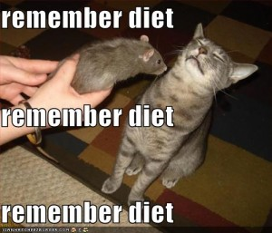
- Offer a high quality “Senior” cat food to supply the right balance of increased nutrients and lower protein and calories.
- Offer more tinned food in the diet to supply more water.
- If they love dry food then offer some teeth-cleaning dry biscuits and don’t forget the raw bones.
- If they have a particular medical problem then there may be a specific diet that will help them. Ask us!

3. Preventative Health Care - parasite control and vaccinations

Treating for internal and external parasites and regular vaccinations are an important part of preventative health programs and protect cats from many nasty diseases. We will advise you on what your cat needs.

4. Don’t miss the warning signs of major health risks

- Drinking more or less than has been usual
- Trouble climbing stairs or jumping up onto the bed
- Smelly breath or drooling
- Changes in sleeping patterns or other behaviours
- Reduced or increased appetite
- Sudden onset of bumping into things
- Unexpected weight loss or gain

Why is it important to look after your pet’s dental health?
Don’t underestimate the seriousness of dental disease to your cat’s health! You may smell bad breath and think nothing of it but this is usually a sign of infection in the mouth. This not only causes pain and loss of teeth but can also affect other organs in the body including the heart and the kidneys.
We brush our teeth twice a day and go to the dentist to have our teeth scaled and polished. If you want your pet to keep their teeth you have to keep them clean! Brushing your pet’s teeth, improving their diet, and having veterinary dental work done when needed can all help them be happier, healthier and live longer.

We offer special senior and elderly cat health consultations.
This can be done when their vaccinations are due or at another time of the year. The following guidelines are for healthy cats with no apparent illnesses. For cats with one or more disease processes we actually create an individual plan for regular check-ups and special testing.

Cats between the ages of 10 and 14 years should have a twice-yearly Health & Happiness Assessment with a Vet. At these visits we will: assess your cat’s general health, weight and condition; examine the joints; check the blood pressure, examine the urine and discuss dental & mental health and nutrition.
We will also do a blood test once a year (more often if illness is detected).

