How To Have A
Healthier, Happier
Senior Dog In Only 30 Days
– Guaranteed !

We will also tell you the 5 common mistakes to avoid that can shorten their life span or decrease their quality of life.

If we surveyed 50 dogs and asked what they wanted to tell you - this is what they would say:

How do I keep healthy & happy?
- I have my food measured out in the mornings to avoid my weight creeping up. My special diet keeps my coat shiny and joints strong (it can even help my brain work better!). I have plenty of fresh water available. Also I have lots of toys and chew treats (never cooked bones) to keep my teeth clean.
- My backyard is secure and well fenced and all those annoying plants like scurvy weed are gone. I have a washable bed to sleep on, raised off the ground to avoid the damp, out of the weather with a blanket to keep me warm in winter. A really thick bed stops my old joints feeling so sore. Sleeping inside is BEST!
- Occasionally I have a bath though I prefer my daily brush. I love spending this time with my human and they can notice any lumps or changes in my skin very early.
- I have a six monthly Health and Happiness Assessment at the veterinary hospital. A full check up lets me avoid months of pain if I have arthritis, gum disease, tooth problems, ear infections, eyelid warts or skin infections.
- We have changed the games we play so that they are less risky for my tendons and joints. Learning new games is fun and keeps me enjoying life.
- A walk in the morning and a trip to the dog park in the afternoon keep me sane. I socialise with other dogs and other people regularly in the street and at the dog park.
Summer Hill Village Vet ph: 02 9797 2555 fx: 02 9797 2566 contact@summerhillvillagevet.com

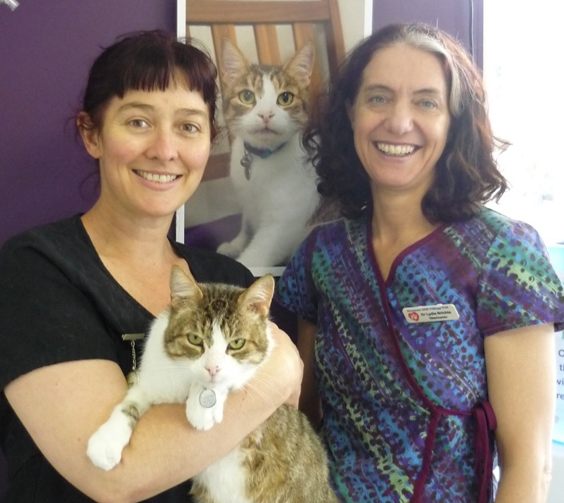
Doctors Sandra Hodgins, Lydia Brichta and Toni Nguyen have over 60 years of Veterinary experience between them.
They all attend continuing education conferences annually as well as evening lectures and on-line webinars practically every month. Take advantage of this combination of personal experience and the latest information by asking for the full special report.
Some special situations you may deal with:
- Blind dogs: Maintain your blind dog's environment with minimal change. Dogs actually adapt amazingly well when they lose their sight - don't move the furniture!
- Deaf dogs: For a dog who lives in a soundless world, sudden contact can be unnerving. It can also be dangerous for the person who delivers the shock! Learn how to let your dog know you're coming and teach any children who have contact how to do so, too. If your dog is completely deaf, step firmly as you approach him - your footfalls will cause a vibration that can be felt even if it's not heard.
- Leaky dogs: If your dog has overnight incontinence, it probably upsets them even more than it upsets you. Take them out last thing before bedtime, and then provide a water-absorbent barrier in their bedding. Whatever you use will need to be washed or replaced daily, but that’s a small price to pay to ensure your senior dog is comfortable. In some cases medications that can solve the problem completely.
Here at Summer Hill Village Vet we want to give you all the advice and support
Summer Hill Village Vet ph: 02 9797 2555 fx: 02 9797 2566 contact@summerhillvillagevet.com

you need to care for your pet at all of their life stages.
Five mistakes to avoid to save your dog’s life:
1. Not taking care of the basics: good diet, vaccinations, worming, flea control etc
2. Not having regular checkups & telling the Vet when you’ve noticed a change: this can mean you miss the chance to cure or treat a problem easily
3. Assuming a problem is old age or not treatable (when it could be arthritis or heart disease or cancer) & then regretting the chance to pursue an effective cure later on.
4. Assuming bad breath is just a nasty smell (when it’s actually a nasty infection)
5. Not investigating lumps (which could be harmless or not at all)
For more in depth information on older dogs ask us for our special report!

